Project Design Phase-II Data Flow Diagram & User Stories

SIMPLE Data flow diagram:

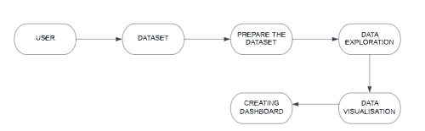

Structural flow diagram:

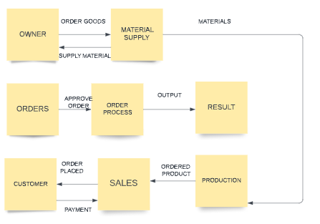

User stories:

|  |  |  |  |  |  |  |
| --- | --- | --- | --- | --- | --- | --- |
| User type | Functional requirement (Epic) | User story number | User story/task | Acceptance criteria | Priority | Release |
| Business owner | Online registration | USN-1 | As a business owner, I want to login to my account. | Input data fields to enter: 1.Username/email 2.Password  3.Re-enter password 4.Security question 5.Security  answer | High | Sprint-1 |
|  | Data upload | USN-2 | As a business owner, I want to upload my sales data to perform  analytics. | Submission of excel file containing the sales data. | High | Sprint-1 |
|  | Improve performance | USN-3 | As a business owner, I want to use the analytics results to make my business performance  better | Reflection of the analytics results to my online store. | High | Sprint-2 |

|  |  |  |  |  |  |  |
| --- | --- | --- | --- | --- | --- | --- |
| Customer (Buyer) | Registration | USN-1 | As a buyer, I want to login to my account | Input data fields to enter: 1.Username/email 2.Password  3.Re-enter password 4.Security question 5.Security  answer | High | Sprint-3 |
|  | Buy | USN-2 | As a buyer, I want to buy products form the online store | Search for the items to buy in the application | Medium | Sprint-3 |
| Analytics team administrator | Analysis of sales data | USN-1 | As an administrator, I want to analyse the sales data for better performance of  the store. | Get the sales data form the business owner. | High | Sprint-4 |